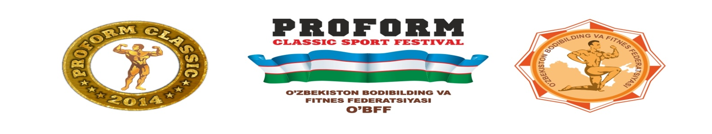
ENTRY FORM
5th annual “Proform Classic Sport Festival”, April 23-27, 2014.
Tashkent, Republic of Uzbekistan
In order to assist in the planning and organization of these event please complete the entry form and return it to the Organizing committee AS SOON AS POSSIBLE BUT NO LATER THAN March 1st, 2014!

FEDERATION NAME:

FAX:

E-MAIL:

DELEGATE:

PASSPORT NUMBER:

Extra DELEGATE:

PASSPORT NUMBER:

Dicipline | Sex |  | Age | Category | Athletes
Bodybuilding | Men |  | Open | Up to 80 kg | 1.
 |  |  |  |  | 2.
 |  |  |  | Up to 90 kg | 1.
 |  |  |  |  | 2.
 |  |  |  | Up to 100 kg | 1.
 |  |  |  |  | 2.
 |  |  |  | Over 100kg | 1.
 |  |  |  |  | 2.
Sports Athletic Physique |  | Women | Open | Open | 1.
 |  |  |  |  | 2.

PLEASE RETURN THE ENTRY FORM, CONFIRMING YOUR PARTICIPATION WITH NAMES OF ALL PARTICIPANTS (DELEGATE, ATHLETES, SUPPORTERS, Extra Delegates ETC.), NO LATER THAN March 1st, 2014.
Please send the completed form to:
proform0322@gmail.com; kotyunya911@mail.ru
Ekaterina Korzun,
Executive Director of the UzBFF.

