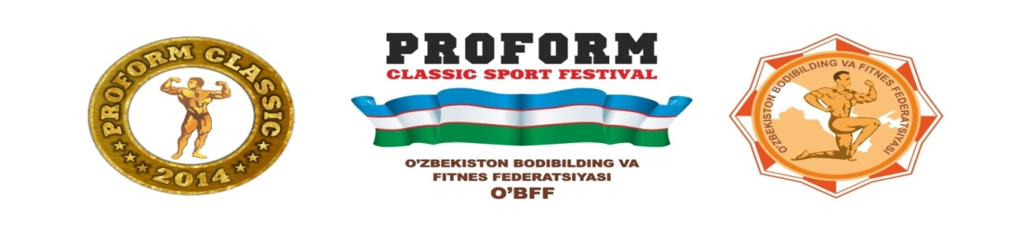
PROFORM Classic Festival
Date | Time | Activity | Venue
April 23rd | 12:00-14:00 | Parade of participants and “PROFORM CLASSIC” opening ceremony. | Ko`rgazna savdo markazi
 | 14:00-18:00 | Uzbekistan weightlifting championships (3 weight categories). | Ko`rgazna savdo markazi
 | 18:00-21:00 | Arm wrestling open championships (World Cup) | Ko`rgazna savdo markazi
April 24th | 15:00-19:00 | Extreme Power Sports World Cup | Ko`rgazna savdo markazi
April 25th | 09:00-12:00 | Bench Press Championships (equipped) and championships among the disabled. | Ko`rgazna savdo markazi
 | 13:00-17:00 | World Cup kettlebell sports championships | Ko`rgazna savdo markazi
 | 18:00-21:00 | Asian Mas-wrestling Championships (Yakut national sports) | Ko`rgazna savdo markazi
April 26th | 12:00-14:00 | Seminar by the bodybuilding legend | Miran International Hotel
 | 17:00-18:30 | Master class by the bodybuilding legend. | PROFORM
April 27th | 19:00-22:00 | Bodybuilding open championships (Night of the Champions) | Concert Hall "Turkestan"

POYTAHT Shopping Сenter, 3rd floor
(landmark “Amir Temur Hiebony” square)
Tashkent, Republic of Uzbekistan
Tel: +998 71 113 23 24; fax: +998 71 113 23 25
e-mail: proform0322@gmail.com; timurkach@gmail.com

